Nuclear Chemistry

Particles
Alpha particle α: two neutrons and two protons bound together and emitted from the nucleus during radioactive decay.
Atomic number decreases by two, mass number decreases by 4
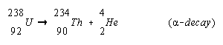
Beta particle β: an electron emitted from the nucleus of a particle during some types of radioactive decay.
Emission –

absorption –

positron – a particle that has the same mass as an electron, but has a positive charge – emitted from the nucleus during some types of radioactive decay.
Gamma rays γ: high energy electromagnetic waves emitted from a nucleus as it undergoes nuclear changes – from an excited state to a ground energy state.
Emission –
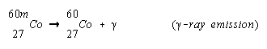

half life – the time required for half of the atoms of a radioactive nuclide to decay.

